REAL TIME WIRE-FRAME POTHOLE DETECTION SYSTEM
PROJECT REPORT

Submitted by
MOHAMED B SIRAJUDDEEN Register No.: 22TD0053
Under the guidance of
Dr. R.G SURESH KUMAR
in partial fulfillment of the requirements for the degree
of

BACHELOR OF TECHNOLOGY

DEPARTMENT OF COMPUTER SCIENCE AND ENGINEERING
RAJIV GANDHI COLLEGE OF ENGINEERING AND TECHNOLOGY
(Approved by AICTE and Affiliated to Pondicherry University)
Accredited with ’A+’ Grade in Cycle II by NAAC
PUDUCHERRY-607402
MAY 2026

RAJIV GANDHI COLLEGE OF ENGINEERING AND TECHNOLOGY
(Approved by AICTE and Affiliated to Pondicherry University)
Accredited with ’A+’ Grade in Cycle II by NAAC

DEPARTMENT OF COMPUTER SCIENCE AND ENGINEERING



BONAFIDE CERTIFICATE

This is to certify that the project work entitled “REAL TIME WIRE-FRAME POTHOLE DETECTION SYSTEM” is a bonafide work done by
MOHAMED B SIRAJUDDEEN [REGISTER No.:22TD0053] in partial fulfillment of the requirement, for the award of B.Tech Degree in Computer Science and Engineering by Pondicherry University during the academic year 2025-2026.

PROJECT GUIDE HEAD OF THE DEPARTMENT

Submitted for the University Examination held on ………………………………………

INTERNAL EXAMINER EXTERNAL EXAMINER

ACKNOWLEDGEMENT

I am very thankful and grateful to my beloved guide, Dr. R.G SURESH KUMAR whose great support in valuable advices, suggestions and tremendous help enabled me in completing my project. He has been a great source of inspiration to me.

I also sincerely thank my Head of the Department, Dr. R.G SURESH KUMAR whose continuous encouragement and sufficient comments enabled me to complete my project report.

I thank all my Staff members who have been by my side always and helped me with my project. I also sincerely thank all the lab technicians for their help as in the course of my project development.

I would also like to extend my sincere gratitude and grateful thanks to our Principal,
Dr. E. VIJAYAKRISHNA RAPAKA for having extended the Research and Development facilities of the department.

I am grateful to our Chairman, Shri. M.K. RAJAGOPALAN. He has been a constant source of inspiration right from the beginning.

We would like to express our faithful and grateful thanks to our Administrator Officer, Name for his support.

I wish to thank my family members and friends for their constant encouragement, constructive criticisms and suggestions that has helped me in timely completion of this project.

ii

ABSTRACT

Road surface irregularities like potholes present major risks to vehicle safety, passenger comfort, and the efficiency of traffic flow. These issues have significant implications in the transportation domain, as they directly affect road safety, traffic management, and overall driving experience. With the growth of autonomous vehicles and smart city initiatives, the need for intelligent systems that can accurately detect and analyze road conditions in real time has become increasingly important.
Traditional approaches for pothole detection have been enhanced through the integration of computer vision and artificial intelligence. These systems utilize cameras to capture road images, which are then processed using deep learning models to detect and classify potholes. By applying AI-based image analysis, the existing methods effectively automate the identification of road surface irregularities, offering a faster and more efficient alternative to manual inspections and sensor-based techniques.
The limitation in existing systems is their reliance on two-dimensional bounding boxes or simple classification, which lack depth and shape information. To address this limitation, my project proposes a Real-Time Wireframe Pothole Detection System that generates a three-dimensional wireframe of road surfaces using camera input. The proposed model aims to integrate depth estimation with wireframe modeling for precise analysis of surface irregularities, enabling better decisions for autonomous vehicles and improving road safety.

Keywords: Real-time detection, Pothole detection, Wireframe modeling, Computer vision, Deep learning.

iii

LIST OF TABLES

TABLE NO. | NAME OF THE TABLE | PAGE NO.
2.6 | Literature Survey Comparison | 19

iv

LIST OF FIGURES

FIGURE NO. NAME OF THE FIGURE PAGE NO.

3.1 Sample Images from PothRGB Dataset 22

3.1.1 Issues in Existing system 24

3.1.2 Existing System Architecture 24

3.2 Flow of Proposed Solution 27

3.2.3 Monocular Vision Algorithm Architecture 29

A1.3.1 Python Installation 36

A1.3.2 Setting up Anaconda Navigator 37

A1.3.3 Drafting Code base 38

A1.3.4 Installation of Virtual Environment 38

A1.3.5 Installation of basic libraries 39

A1.4.1 Picasso Dataset precision-recall curves 39

A1.4.2 Comparison of YOLO models 40

v

LIST OF ABBREVIATIONS

AI – Artificial Intelligence
ML – Machine Learning
DL – Deep Learning
CV – Computer Vision
CNN – Convolutional Neural Network
DNN – Deep Neural Network
YOLO – You Only Look Once
YOLOv5 – You Only Look Once Version 5
YOLOv6 – You Only Look Once Version 6
YOLOv7 – You Only Look Once Version 7
YOLOv8 – You Only Look Once Version 8
RGB – Red, Green, Blue
RGB-D – Red, Green, Blue with Depth
LiDAR – Light Detection and Ranging
GNSS – Global Navigation Satellite System
FPS – Frames Per Second
FOV – Field of View
GPU – Graphics Processing Unit
CPU – Central Processing Unit
RAM – Random Access Memory
SSD – Solid State Drive
RNN – Recurrent Neural Network
SLAM – Simultaneous Localization and Mapping
TSDF – Truncated Signed Distance Function
API – Application Programming Interface

vi
TABLE OF CONTENTS
CHAPTER NO. | TITLE | PAGE NO.
ABSTRACT iii
LIST OF TABLES iv
LIST OF FIGURES v
LIST OF ABBREVIATIONS vi
- INTRODUCTION 1
  - ARTIFICIAL INTELLIGENCE 1
  - AUTONOMOUS VEHICLES 1
    - Road Surface Perception 2
    - Vision-Based Structural Understanding of
Road Defects 3
    - Real-Time Structural Modeling 4
  - COMPUTER VISION SYSTEM ARCHITECTURE 6
    - Image Acquisition and Preprocessing 6
    - Deep Learning-Based Pothole Detection 7
    - Monocular Depth Estimation 7
    - Wireframe and Geometric Modeling 8
  - REAL-TIME PROCESSING FRAMEWORK 8
    - Detection Pipeline and Data Flow 9
    - Temporal Consistency and Frame
Stabilization 9
    - Computational Optimization for
Real-Time Execution 10

  - SYSTEM APPLICATIONS AND USE CASES 10
    - Autonomous Navigation Assistance 10
    - Road Infrastructure Monitoring 11
    - Safety and Decision Support Systems 11
  - NEED FOR THE PROJECT 12
  - OBJECTIVE OF THE PROJECT 12
- LITERATURE SURVEY 14
  - LITERATURE SURVEY – I 14
  - LITERATURE SURVEY – II 15
  - LITERATURE SURVEY – III 16
  - LITERATURE SURVEY – IV 17
  - LITERATURE SURVEY – V 18
  - LITERATURE SURVEY COMPARISON 19
- SYSTEM STUDY 21
  - EXISTING SYSTEM 21
    - Issues in the system 22
    - Existing system architecture 25
    - Solutions 25
  - PROPOSED SYSTEM 25
3.2.1 Concept of monocular vision–based
3d wireframe reconstruction 27
3.2.2 Working of monocular vision–based
3d wireframe reconstruction 28
3.2.3 Monocular Vision Algorithm Architecture 29
- SYSTEM REQUIREMENTS 30
  - HARDWARE REQUIREMENTS 30
  - SOFTWARE REQUIREMENTS 30
- DESIGN AND IMPLEMENTATION 34

5.1 SYSTEM ARCHITECTURE 34
5.2 IMPLEMENTATION DETAILS 35
5.2.1 Name of Module 1(Along with Description) 35
5.2.2 Name of Module 2 (Along with Description) 36
- RESULT AND DISCUSSION 37
6.1 DISCUSSION 37
6.2 RESULT COMPARISON 38
7. CONCLUSION & FUTURE ENHANCEMENT 32
7.1 CONCLUSION 32
7.2 FUTURE ENHANCEMENT 33

APPENDIX 34
APPENDIX 1 35
APPENFIX 2 36
REFERENCES 41
CHAPTER I

INTRODUCTION

  - ARTIFICIAL INTELLIGENCE

Artificial Intelligence (AI) is a branch of computer science that focuses on designing systems capable of performing tasks that normally require human intelligence. These tasks include perception, learning, reasoning, decision-making, and problem solving. AI systems are developed to analyze large volumes of data, identify meaningful patterns, and make predictions or decisions with minimal human intervention. With the rapid growth of computational power and availability of data, AI has evolved from rule-based systems to advanced learning-based models that can adapt and improve over time [4], [17].

Modern AI heavily relies on techniques such as Machine Learning and Deep Learning, where algorithms learn directly from data instead of being explicitly programmed. These approaches enable systems to handle complex, unstructured data such as images, videos, audio, and sensor signals. As a result, AI has found widespread applications in domains such as healthcare, autonomous vehicles, robotics, finance, smart cities, and intelligent transportation systems [3], [18].

In real-world scenarios, AI plays a crucial role in automating perception-driven tasks that require speed, accuracy, and consistency beyond human capability. In the context of road safety and autonomous navigation, AI enables vehicles to understand their surroundings, detect anomalies, and make informed decisions in real time [5], [7]. The integration of AI with computer vision allows machines to interpret visual information from cameras and extract meaningful insights, making it a foundational technology for advanced driver-assistance systems and intelligent infrastructure monitoring.

  - AUTONOMOUS VEHICLES

Autonomous vehicles are intelligent transportation systems capable of sensing their environment, interpreting surrounding conditions, and navigating without direct human control. These vehicles rely on a combination of sensors, embedded computing, artificial intelligence, and control algorithms to perceive the road, detect obstacles, and make real-time driving decisions. By continuously analyzing data from cameras and other sensing devices, autonomous vehicles aim to improve road safety, reduce human error, and enhance driving efficiency. They play a vital role in modern transportation by enabling features such as lane keeping, obstacle avoidance, adaptive speed control, and automated path planning. As autonomous driving technology advances, accurate perception of road conditions—including surface anomalies such as potholes—becomes critical for ensuring vehicle stability, passenger comfort, and safe navigation [1], [2].

    - ROAD SURFACE PERCEPTION

Road surface perception is a critical component of autonomous vehicle research, as road conditions directly influence vehicle safety, stability, comfort, and decision-making [3], [5]. Unlike static obstacles such as vehicles or pedestrians, road surface anomalies are part of the driving terrain and continuously interact with vehicle wheels, suspension, and control systems. Irregularities such as potholes, cracks, and uneven pavement can adversely affect steering, braking, and ride quality, making reliable road surface perception essential for safe autonomous navigation.

In autonomous driving systems, perception modules transform raw sensor data into meaningful environmental understanding. Road surface perception extends beyond obstacle detection by requiring detailed analysis of geometric and textural variations that indicate surface degradation. Potholes often lack clear visual boundaries and may resemble shadows or stains, making them difficult to detect using conventional 2D object detection techniques Consequently, continuous surface analysis is necessary for accurate identification [11].

Vision-based perception systems are widely adopted due to their cost-effectiveness and compatibility with existing vehicle platforms. Cameras capture rich visual cues such as texture and shading, enabling detection of damaged road regions. However, environmental factors including lighting variations, shadows, and reflections can degrade accuracy when relying solely on image appearance. To address this, modern approaches employ deep learning models that learn robust hierarchical features, improving discrimination between potholes and visually similar patterns [21], [22].

Since potholes are inherently three-dimensional, depth perception plays a vital role in assessing their severity. While LiDAR and stereo vision provide accurate depth information, their cost and complexity limit large-scale deployment. Recent advances in monocular depth estimation allow depth inference from a single RGB camera, offering a cost-efficient and real-time alternative. Integrating depth estimation with vision-based detection enables proactive decision-making, such as controlled deceleration or path adjustment, and improves navigation reliability. Overall, road surface perception forms the foundation for depth-aware and structurally informed autonomous driving systems, motivating the proposed real-time wireframe-based approach [9].

    - VISION-BASED STRUCTURAL UNDERSTANDING OF ROAD DEFECTS

Recent research in autonomous driving emphasizes the need for pothole detection systems that extend beyond conventional two-dimensional object detection toward structural understanding of road defects. While early approaches relied on bounding boxes or segmentation masks to identify potholes, such representations provide limited insight into their physical characteristics. Potholes are inherently three-dimensional structures defined by depth, shape, and boundary geometry, and understanding these properties is essential for reliable decision-making in autonomous vehicles [13].

Traditional 2D detection methods treat potholes as visual objects, offering computational efficiency but failing to capture geometric complexity. A bounding box does not convey critical information such as depth or severity, which can result in underestimating or overestimating the hazard posed by a road defect. To address this limitation, recent studies incorporate geometry-aware perception, enabling systems to infer the three-dimensional structure of potholes rather than merely detecting their presence [15].

Monocular camera-based systems have emerged as a cost-effective solution for achieving structural understanding. Advances in deep learning enable depth estimation from a single RGB image by learning geometric cues such as perspective, texture gradients, and object scale. When combined with vision-based pothole detection, monocular depth estimation allows autonomous systems to infer relative depth and shape without relying on expensive LiDAR or stereo sensors [20].

Structural understanding is further enhanced through wireframe or mesh representations, which model potholes using connected edges or polygons to describe their spatial extent and depth variations. Wireframe modeling enables precise boundary localization and quantitative severity analysis, supporting informed behavioral planning such as controlled deceleration or path adjustment. Real-time implementation of these techniques requires efficient model design and temporal consistency to ensure stable perception across consecutive frames [9].

Overall, vision-based structural understanding represents a significant advancement in road surface perception. By integrating depth estimation and wireframe modeling with pothole detection, autonomous systems gain meaningful geometric insight into road anomalies . This enables safer navigation decisions and forms the foundation for real-time, structure-aware pothole detection systems such as the proposed work [9].

    - REAL-TIME STRUCTURAL MODELING

Real-time structural modeling enables autonomous systems to interpret detected road anomalies in a geometric form suitable for navigation, control, and decision-making. Unlike traditional perception methods that represent potholes as two-dimensional regions or bounding boxes, structural modeling captures essential spatial characteristics such as depth, shape, slope, and boundary geometry. This geometric representation provides meaningful insight into how road anomalies physically interact with vehicle dynamics, which is crucial for safe and reliable autonomous operation [9], [13].

Autonomous vehicles operate under strict real-time constraints, requiring perception and planning modules to produce accurate results with minimal latency. The goal of real-time structural modeling is not exact surface reconstruction but generating a sufficiently detailed approximation that supports immediate driving decisions. Achieving an effective balance between geometric accuracy and computational efficiency remains a key research challenge [4], [17].

Wireframe and mesh-based representations are commonly used to model pothole geometry. Wireframe models describe potholes using interconnected edges that highlight boundaries and depth variations while remaining computationally lightweight. Mesh-based representations further approximate surface topology using connected polygons. Both approaches offer significant advantages over flat 2D representations by explicitly encoding three-dimensional structure [8], [13].

Structural modeling enables quantitative severity assessment of potholes by analyzing depth deviation and affected surface area. This information allows autonomous systems to distinguish minor surface irregularities from critical hazards and plan appropriate responses. Geometric representations directly support path planning and motion control by enabling safe trajectory computation around damaged regions with minimal lateral deviation [1], [15].

Speed regulation is another key application of structural modeling. By evaluating pothole depth and slope, autonomous vehicles can compute controlled deceleration profiles that reduce suspension stress and improve passenger comfort. Structural modeling also integrates road anomalies into the broader obstacle avoidance framework, allowing unified reasoning with other static and dynamic obstacles [7].

To meet real-time requirements, structural modeling pipelines rely on optimized algorithms, lightweight neural networks, and efficient data processing. Temporal consistency further ensures stable geometric representations across consecutive frames, preventing erratic vehicle behavior. Beyond navigation, aggregated structural data supports large-scale road condition monitoring and infrastructure management [11]. Overall, real-time structural modeling bridges perception and control by enabling geometry-aware understanding of road surfaces, forming a critical foundation for advanced autonomous driving systems.

  - COMPUTER VISION SYSTEM ARCHITECTURE

Computer vision system architecture forms the backbone of intelligent perception in autonomous and driver-assistance systems. It defines how raw visual data acquired from sensors is transformed into meaningful representations that support decision-making [5]. In the context of road surface analysis and pothole detection, the architecture must efficiently integrate image acquisition, feature extraction, depth estimation, and geometric modeling while maintaining real-time performance [14], [15].

A well-designed computer vision architecture ensures modularity, scalability, and robustness [4]. Each stage of the pipeline performs a specific function, allowing independent optimization and easier system upgrades. For real-time pothole detection, the architecture must balance computational efficiency with perceptual accuracy, as delayed or incorrect perception can lead to unsafe navigation decisions. The proposed system architecture focuses on a sequential yet tightly coupled pipeline that converts raw camera input into a structured wireframe representation of road surface anomalies [9], [13].

    - IMAGE ACQUISITION AND PREPROCESSING

Image acquisition is the initial stage of the computer vision pipeline, where visual data of the road surface is captured using an RGB camera. In autonomous vehicle applications, cameras are typically mounted at fixed positions to provide a forward-facing view of the driving environment. The quality of captured images directly affects the performance of subsequent processing stages, making reliable acquisition essential [4], [18].

Raw images often contain noise, illumination variations, motion blur, and perspective distortions caused by vehicle movement and environmental conditions. Preprocessing techniques are applied to enhance image quality and standardize input data for deep learning models. Common preprocessing steps include resizing, normalization, noise reduction, contrast enhancement, and color space conversion. These operations improve feature visibility and reduce sensitivity to lighting changes, shadows, and surface reflections [1].

Effective preprocessing ensures that the deep learning models focus on relevant road features rather than artifacts. In real-time systems, preprocessing must be computationally lightweight to avoid introducing latency. Therefore, only essential transformations are applied to maintain a balance between image enhancement and processing speed [2], [7].

    - DEEP LEARNING–BASED POTHOLE DETECTION

Deep learning–based pothole detection is a core component of the computer vision architecture. Convolutional Neural Networks (CNNs) are widely used for this task due to their ability to automatically learn hierarchical features from visual data. These features capture texture patterns, edge information, and contextual cues that distinguish potholes from normal road surfaces [1], [11].

Modern object detection models such as YOLO (You Only Look Once) are particularly suited for real-time applications. They perform detection in a single forward pass, enabling high-speed inference while maintaining acceptable accuracy. In pothole detection, the model identifies regions of interest where road surface anomalies are likely present [2], [22].

Unlike traditional image processing methods that rely on handcrafted features, deep learning models adapt to diverse road conditions through training on large datasets [18], [19]. This adaptability improves robustness under varying lighting, weather, and pavement conditions. However, deep learning models primarily operate in two-dimensional space, necessitating additional processing to extract structural information from detected pothole regions.

    - MONOCULAR DEPTH ESTIMATION

Monocular depth estimation enhances the perception pipeline by providing three-dimensional context using a single RGB image. Depth estimation is critical for understanding the physical severity of potholes, as visual appearance alone cannot reliably indicate depth or volume [1], [13].

Recent advances in deep learning have enabled accurate depth estimation from monocular images by learning geometric priors from large-scale datasets [12], [19]. These models analyze visual cues such as perspective, shading, and texture gradients to infer relative depth. Although monocular depth estimation does not provide absolute measurements comparable to LiDAR, it offers sufficient accuracy for navigation and decision-making [19], [20].

Integrating depth estimation into the pothole detection pipeline allows the system to evaluate how deeply the road surface deviates from its normal plane. This information is essential for determining appropriate vehicle responses, such as speed reduction or path adjustment. Monocular depth estimation provides a cost-effective alternative to sensor-heavy systems, making it suitable for scalable autonomous applications [4], [13].

    - WIREFRAME AND GEOMETRIC MODELING

Wireframe and geometric modeling convert depth-enhanced pothole detections into structured representations of road surface anomalies [9], [13]. A wireframe model outlines the geometric boundaries and internal structure of a pothole using interconnected edges and vertices. This representation captures shape, size, and spatial extent while remaining computationally efficient.

Geometric modeling enables quantitative analysis of potholes, including boundary estimation and surface profiling. Unlike flat segmentation masks, wireframe representations preserve three-dimensional relationships, allowing the system to reason about how a pothole interacts with vehicle dynamics [1], [5]. This structured understanding is essential for downstream modules such as path planning and motion control.

In real-time systems, wireframe modeling must be optimized to avoid excessive computation [9], [13]. By focusing only on detected regions of interest, the system minimizes processing overhead while maintaining accurate structural representation.

  - REAL-TIME PROCESSING FRAMEWORK

The real-time processing framework governs how the computer vision pipeline operates under strict latency constraints. Autonomous vehicles require perception, analysis, and decision-making to occur within milliseconds to ensure safe operation. The framework coordinates data flow between modules and ensures timely execution of each processing stage [4].

Real-time performance is achieved through efficient model design, optimized data handling, and parallel execution where possible. The framework prioritizes critical perception tasks and minimizes redundant computation [2]. This ensures that the system remains responsive even in complex driving environments.

    - DETECTION PIPELINE AND DATA FLOW

The detection pipeline defines the sequence of operations that transform raw camera input into actionable information. Visual data flows from image acquisition to preprocessing, pothole detection, depth estimation, and geometric modeling. Each stage produces intermediate outputs that serve as inputs to subsequent modules [1], [14].

Efficient data flow management reduces memory overhead and latency. Intermediate representations are kept compact, and unnecessary data duplication is avoided. A well-structured pipeline ensures smooth integration of perception outputs with navigation and control systems [9].

    - TEMPORAL CONSISTENCY AND FRAME STABILIZATION

Temporal consistency is essential for maintaining stable perception results across consecutive frames. Road anomalies persist over time, and their detection and structural representation should remain consistent. Without temporal stabilization, perception outputs may fluctuate, leading to erratic vehicle behavior [9], [15].

Frame-to-frame consistency techniques such as temporal smoothing and region tracking reduce noise in detection and depth estimation [14], [15]. These techniques improve reliability and confidence in the perception system, enabling smoother control decisions.

    - COMPUTATIONAL OPTIMIZATION FOR REAL-TIME EXECUTION

Computational optimization ensures that the perception system meets real-time constraints without sacrificing accuracy [2], [23]. Lightweight neural networks, reduced input resolutions, and selective processing of regions of interest are commonly employed optimization strategies.

Hardware acceleration using GPUs further enhances processing speed. Optimization techniques enable deployment on embedded platforms commonly used in autonomous vehicles, ensuring scalability and practical applicability [7], [9].

  - SYSTEM APPLICATIONS AND USE CASES

The proposed computer vision system supports multiple applications within autonomous driving and intelligent transportation systems. Its ability to detect and structurally model road anomalies extends its usefulness beyond basic perception tasks.

    - AUTONOMOUS NAVIGATION ASSISTANCE

In autonomous navigation, the system provides critical information about road surface conditions to support safe driving decisions [3], [18]. Structural modeling of potholes enables proactive speed adjustment and trajectory planning, reducing the risk of vehicle damage and passenger discomfort.

In addition to supporting proactive speed regulation and trajectory planning, the system improves navigation reliability under challenging road conditions such as low visibility, uneven terrain, and high-speed driving scenarios. By continuously analyzing road surface geometry, the perception module enables autonomous vehicles to anticipate hazards well in advance and respond smoothly rather than relying on reactive maneuvers. The wireframe representation of potholes allows navigation algorithms to compute safer paths that minimize abrupt steering or braking actions, thereby improving vehicle stability and passenger comfort. This capability is particularly beneficial in urban environments where road degradation is frequent and unpredictable [1], [2].

    - ROAD INFRASTRUCTURE MONITORING

Aggregated perception data can be used for large-scale road condition monitoring. Structural representations of potholes collected by vehicles enable automated infrastructure assessment and predictive maintenance planning, reducing reliance on manual inspections [1], [11].

Beyond real-time vehicle operation, the system enables long-term infrastructure analysis by collecting structured road surface data across multiple trips and locations. The geometric attributes of detected potholes, such as depth and affected area, provide quantitative indicators of road deterioration severity. When aggregated over time, this information can be used to identify high-risk zones, monitor the progression of road damage, and prioritize maintenance efforts. Automated infrastructure monitoring using vision-based structural data significantly reduces inspection costs and enables data-driven decision-making for transportation authorities [1], [15].

    - SAFETY AND DECISION SUPPORT SYSTEMS

The system enhances safety by providing reliable, geometry-aware perception of road hazards. Decision support mechanisms use this information to trigger warnings, adjust driving behavior, or inform higher-level control systems. Accurate road surface perception directly contributes to safer and more resilient autonomous vehicle operation [3], [17].

The system also serves as a critical input to higher-level safety and decision support frameworks within autonomous vehicles. Geometry-aware perception allows the system to assess hazard severity more accurately and differentiate between minor surface imperfections and critical road defects. Based on this assessment, appropriate safety actions such as warning generation, controlled deceleration, or rerouting can be initiated. The integration of structural road information into decision support systems enhances situational awareness and reduces the likelihood of unsafe maneuvers, contributing to more reliable and resilient autonomous vehicle operation [9].

1.6 NEED FOR THE PROJECT

Road surface anomalies such as potholes pose a significant challenge to both autonomous and human-driven vehicles, directly impacting road safety, vehicle stability, passenger comfort, and infrastructure durability. Existing pothole detection systems largely depend on expensive sensor setups involving LiDAR and GNSS or rely on post-processed data intended for road maintenance rather than real-time vehicle navigation. These approaches introduce high hardware costs, increased power consumption, and system complexity, limiting their scalability and adoption in cost-sensitive and mass-market vehicles. Furthermore, many vision-based methods provide only two-dimensional detection, failing to capture the structural severity of potholes required for informed driving decisions. Therefore, there is a critical need for a lightweight, cost-effective, and real-time perception system that can accurately detect potholes and understand their geometric characteristics using minimal hardware. This project addresses this need by focusing on camera-only perception and structural modeling, enabling scalable deployment and proactive autonomous navigation [5].

  - OBJECTIVE OF THE PROJECT

The objectives of the project include:

- To design a real-time vision-based pothole detection system using a single RGB camera [2].

- To eliminate dependency on LiDAR and GNSS, reducing hardware cost and system complexity [4].

- To implement monocular depth estimation for understanding the three-dimensional structure of potholes [6].

- To generate a wireframe-based geometric representation of road surface anomalies [9].

- To enable geometry-aware decision support for autonomous navigation, including speed regulation and path adjustment [17].

- To ensure low-latency and computational efficiency suitable for real-time deployment [23].

- To improve robustness of pothole detection under varying road and environmental conditions [14].

- To support scalability for mass-market vehicles and intelligent transportation systems [3].

CHAPTER II

LITERATURE SURVEY

2.1 LITERATURE SURVEY – I

TITLE: An Enhanced YOLOv8 Model for Real-Time and Accurate Pothole Detection and Measurement

AUTHORS: Mustafa Yurdakul, Şakir Taşdemir

YEAR: 2025

DESCRIPTION:

Their paper proposes an enhanced YOLOv8-based segmentation model for real-time pothole detection and physical measurement using RGB-D data. The authors collect synchronized RGB and depth images using an Intel RealSense D415 camera and introduce the publicly available PothRGBD dataset labeled for segmentation. The standard YOLOv8n-seg model is improved by integrating Dynamic Snake Convolution (DSConv) for better handling of irregular pothole boundaries, the SimAM attention module to highlight informative regions, and the GELU activation function to improve learning stability. In addition to detecting potholes, the system accurately estimates pothole perimeter and depth by combining segmentation outputs with depth maps. The primary objective is to overcome the limitations of 2D vision-based methods by enabling accurate physical characterization of potholes while maintaining low computational complexity and real-time performance.

CONCLUSION:

I conclude that their work effectively demonstrates the importance of geometry-aware segmentation and depth integration for reliable pothole detection and measurement. The use of DSConv and attention mechanisms improves boundary accuracy for irregular road defects, while segmentation-based depth analysis enables meaningful physical interpretation of potholes. From this study, I infer that precise boundary extraction and depth-informed modeling are essential for advanced road surface understanding. These techniques can be adapted to our project by employing similar segmentation strategies and structural analysis while replacing RGB-D sensors with monocular depth estimation, thereby supporting the development of a real-time wireframe pothole detection system focused on geometric representation and autonomous navigation support.

2.2 LITERATURE SURVEY – II

TITLE: Robust Video-Based Pothole Detection and Area Estimation for Intelligent Vehicles with Depth Map and Kalman Smoothing

AUTHORS: Dehao Wang, Haohang Zhu, Yiwen Xu, And Kaiqi Liu

YEAR: 2025

DESCRIPTION:

Their paper presents a vision-based pothole detection and classification system designed for autonomous driving applications. The authors use a deep convolutional neural network as a feature extractor and combine it with machine learning classifiers optimized using meta-heuristic algorithms. To address dataset imbalance, oversampling techniques are applied, improving classification robustness. The system focuses on accurate identification of potholes from road images under varying conditions and achieves high classification performance, demonstrating the effectiveness of deep feature extraction combined with optimized learning strategies.

CONCLUSION:

I conclude that their work demonstrates the reliability of deep learning–based visual features for pothole detection in real-world scenarios. However, the approach is limited to two-dimensional classification and does not analyze the physical structure of potholes. The feature extraction and optimization strategies from this paper can be adopted in my project and extended with depth estimation and geometric modeling to enable structural understanding and wire-frame representation of road surface anomalies.

2.3 LITERATURE SURVEY – III

TITLE: Mobile3DRecon: Real-time Monocular 3D Reconstruction on a Mobile Phone

AUTHORS: Xingbin Yang, Liyang Zhou, Hanqing Jiang, Zhongliang Tang, Yuanbo Wang, Hujun Bao, Guofeng Zhang

YEAR: 2020

DESCRIPTION:

Their paper proposes a real-time 3D scene reconstruction framework using multiple RGB-D cameras to generate stable triangle meshes for dynamic environments. The authors integrate moving least squares (MLS) surface reconstruction with GPU-accelerated mesh generation to smooth noisy depth data and ensure temporal stability. The system efficiently produces consistent geometric representations suitable for real-time applications such as robotics and augmented reality.

CONCLUSION:

I conclude that their work establishes an effective methodology for real-time geometric modeling and mesh generation. Although the system relies on RGB-D sensors, the concepts of surface smoothing, structural reconstruction, and real-time mesh generation are directly relevant to my project. These techniques inspire my wire-frame modeling stage, which adapts similar geometric principles using monocular depth estimation instead of dedicated depth sensors.

2.4 LITERATURE SURVEY – IV

TITLE: Pothole and Plain Road Classification Using Adaptive Mutation Dipper Throated Optimization and Transfer Learning for Self-Driving Cars.

AUTHORS: Amel Ali Alhussan, Doaa Sami Khafaga, El-Sayed M. El-Kenawy,
Abdelhameed Ibrahim, Marwa Metwally Eid, Abdelaziz A. Abdelhamid

YEAR: 2022

DESCRIPTION:

Their paper focuses on detecting road surface defects using deep learning–based computer vision techniques. The proposed approach leverages convolutional neural networks to learn robust texture and shape features from road images, improving detection performance under challenging conditions such as shadows, varying illumination, and surface noise. The study highlights the superiority of learned features over traditional handcrafted image processing methods.

CONCLUSION:

I conclude that this work highlights the importance of robust feature learning for reliable road surface perception. While the system effectively detects defects, it does not provide depth or geometric interpretation of potholes. The insights from this paper support our use of deep learning for perception and motivate extending detection toward depth-aware and structural representations in my real-time wire-frame pothole detection system.

2.5 LITERATURE SURVEY – V

TITLE: Real-time scene reconstruction and triangle mesh generation using multiple RGB-D cameras

AUTHORS: Siim Meerits, Vincent Nozick, Hideo Saito

YEAR: 2017

DESCRIPTION:

Their paper presents an automated pothole detection approach using machine learning and computer vision techniques. The authors extract visual features from road images and apply classification models to identify potholes, emphasizing scalability and suitability for intelligent transportation systems. The proposed method demonstrates improved accuracy compared to traditional feature-based approaches.

CONCLUSION:

I conclude that their study confirms the effectiveness of vision-based pothole detection for large-scale deployment. However, the lack of geometric and depth analysis limits its applicability to autonomous navigation. My project builds upon this limitation by incorporating depth estimation and wire-frame modeling, enabling precise structural understanding of potholes for real-time decision-making in autonomous vehicles.

2.6 LITERATURE SURVEY COMPARISON:

Sl. No | Title | Technology Used | Conclusion
 | An Enhanced YOLOv8 Model for Real-Time and Accurate Pothole Detection and Measurement. | YOLOv8n-seg,  DSConv,  SimAM,  GELU activation. | I conclude that integrating DSConv and SimAM into a YOLOv8 seg yields more accurate pothole masks and reliable physical measurements, which I can apply to my project to get precise segmentation masks and direct depth/perimeter estimates.
 | Robust Video-Based Pothole Detection and Area Estimation for Intelligent Vehicles with Depth Map and Kalman Smoothing | ACSH-YOLOv8,  BoT-SORT,  EMC,  DepthAnything,  MBTP,  CDKF. | I conclude that integrating enhanced object detection, monocular depth estimation, pixel-level area computation, and Kalman-based smoothing can significantly improve the precision and reliability of pothole detection.
 | Mobile3DRecon: Real-time Monocular 3D Reconstruction on a Mobile Phone | Monocular camera,  6DoF SLAM,  SGM,  DNN,  TSDF voxel fusion,  Mesh generation | I conclude that their mobile-focused, CPU-based incremental mesh generation offers techniques and system design ideas directly applicable to resource-constrained 3D reconstruction tasks like pothole mapping or detection.
 | Pothole and Plain Road Classification Using Adaptive Mutation Dipper Throated Optimization and Transfer Learning for Self-Driving Cars. | ResNet-50,  Binary Advanced Mutation,  Dipper Throated Optimization,  SMOTE,  Random Forest,  AMDTO optimizer. | I conclude that applying meta-heuristic optimization for feature selection and classifier tuning together with an improved SMOTE balancing step can dramatically boost pothole vs plain-road classification accuracy.
 | Real-time scene reconstruction and triangle mesh generation using multiple RGB-D cameras | Point cloud smoothing,  Mesh zippering,  Direct triangle mesh generation,  Mesh merging. | I conclude that their GPU-parallel mesh approach, gives insight into achieving fast, reliable surface modeling—enhancing the efficiency of mesh processing in pothole detection systems.

Table 2.6: Literature Survey Comparison

CHAPTER III

SYSTEM STUDY

3.1 EXISTING SYSTEM

Existing pothole detection and road maintenance systems primarily rely on a combination of vision-based, vibration-based, and depth-based sensing approaches to identify and characterize road surface defects. Among these, recent systems have shown a growing preference for sensor fusion techniques, integrating camera and LiDAR data to overcome the limitations of individual sensing modalities. A representative existing system integrates RGB camera data with LiDAR-based depth sensing to enable accurate detection, geometric characterization, and geo-positioning of potholes for automated road inspection and maintenance [1].

In the existing system, visual data captured by an RGB camera is processed using deep learning–based object detection models, particularly the YOLO family of architectures. Multiple YOLO variants, including YOLOv5, YOLOv6, YOLOv7, and YOLOv8, are trained and evaluated for pothole detection performance, with YOLOv5 selected for real-time deployment due to its balance between accuracy and computational efficiency. The camera-based detection provides two-dimensional localization of potholes in the form of bounding boxes, which serve as the initial stage of the perception pipeline [1], [22].

To address the lack of depth information inherent in camera-only systems, LiDAR sensors are integrated into the existing framework. Camera–LiDAR calibration is performed to align visual detections with corresponding three-dimensional point cloud data. Once a pothole is detected in the image frame, the bounding box coordinates are projected onto the LiDAR point cloud to extract depth information associated with the detected region. This sensor fusion approach enables the system to compute geometric attributes such as pothole depth, surface area, and volume using algorithms like the Convex Hull method [1].

Additionally, the existing system incorporates GNSS-based geo-positioning to map detected potholes accurately on a geographic coordinate system. This allows potholes to be visualized on interactive maps along with their computed geometric properties, supporting road maintenance planning and prioritization. Field deployment of such systems has demonstrated the ability to detect and characterize potholes in real-world road environments with reasonable accuracy and reliability [1], [10].

While the existing system provides detailed geometric characterization of potholes and significantly reduces manual inspection effort, it exhibits certain limitations. The reliance on LiDAR and GNSS increases hardware cost, power consumption, and system complexity, limiting scalability and mass deployment. Furthermore, the perception pipeline focuses primarily on feature extraction and road maintenance applications rather than real-time navigation or autonomous vehicle decision-making. These limitations motivate the need for a more cost-effective, camera-only solution capable of real-time structural understanding, which forms the basis for the proposed system [2], [9].

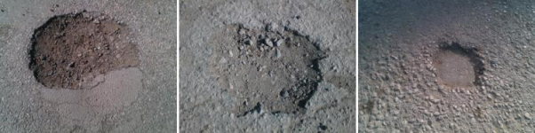

Figure 3.1 Sample Images from PothRGB Dataset

3.1.1 ISSUES IN THE SYSTEM

- High Hardware Cost

The use of LiDAR and GNSS significantly increases system cost, making deployment in low-cost or mass-market vehicles impractical [4], [20].

- Increased Power Consumption

LiDAR and GNSS sensors require substantial power, reducing efficiency and suitability for long-term autonomous operation [15].

- System Complexity

Sensor fusion architectures introduce additional computational and architectural complexity, increasing maintenance and integration challenges [1].

- Calibration Sensitivity

Camera–LiDAR calibration is sensitive to sensor misalignment, vibrations, and environmental disturbances, leading to degradation in depth accuracy over time [1], [7].

- Weather Dependency

LiDAR-based sensing is adversely affected by rain, fog, and dust, reducing reliability in real-world driving conditions [3].

- Lack of Real-Time Decision Support

Existing systems primarily generate post-processed data for road maintenance rather than supporting low-latency, real-time navigation decisions [1], [11].

- Limited Structural Understanding

Reliance on 2D bounding boxes with external depth extraction fails to provide continuous and detailed geometric representation of potholes [15].

- Poor Scalability

Due to high cost, complexity, and hardware dependency, the system does not scale well for large-scale or widespread deployment [9], [15].

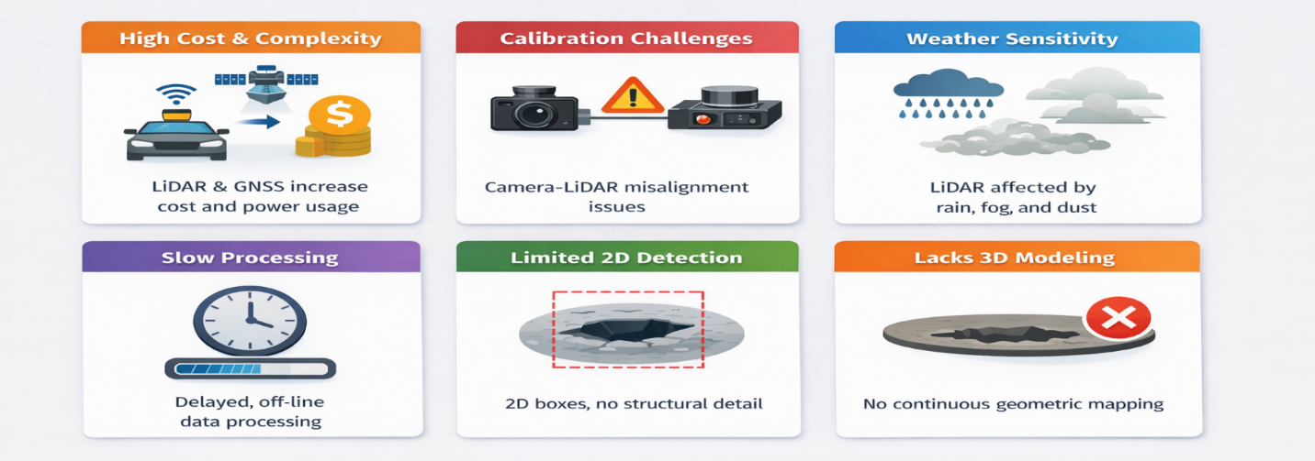

Figure 3.1.1 Issues in Existing system

3.1.2 EXISTING SYSTEM ARCHITECTURE

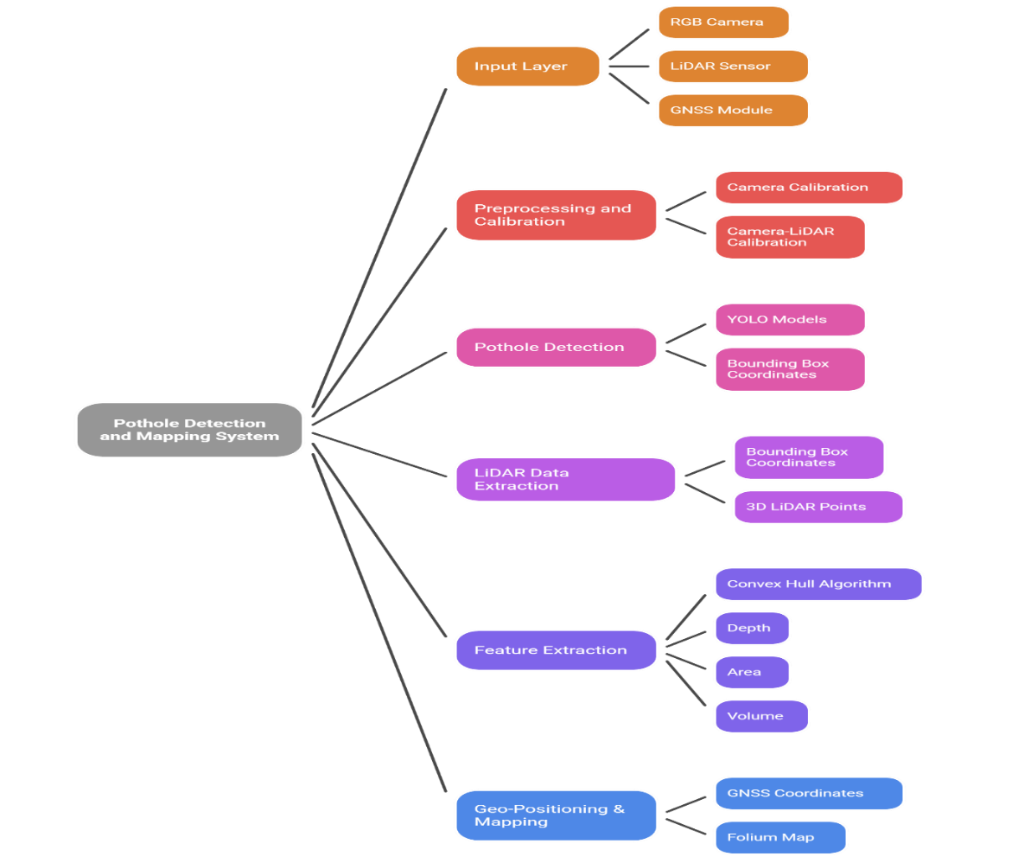

Figure 3.1.2 Existing System Architecture

3.1.3 SOLUTIONS

To overcome the limitations of existing LiDAR-dependent pothole detection systems, the proposed solution introduces a camera-only, real-time wireframe pothole detection system that eliminates the need for expensive depth sensors and complex sensor calibration. The system relies on a single RGB camera combined with deep learning–based vision models to perform accurate pothole detection, depth estimation, and structural modeling in real time [2].

Instead of using LiDAR for depth extraction, the proposed approach employs monocular depth estimation techniques to infer relative depth information directly from visual input, enabling three-dimensional understanding of road surface anomalies without additional hardware. Detected potholes are further processed to generate a wireframe or geometric representation that captures boundary shape, depth variation, and spatial extent, providing continuous structural insight rather than discrete 2D bounding boxes [9], [13].

This lightweight perception pipeline is designed for low latency and reduced computational overhead, making it suitable for real-time autonomous navigation and scalable deployment. By focusing on structural understanding and real-time decision support, the proposed system addresses cost, scalability, and operational limitations of existing approaches while enabling proactive driving actions such as controlled deceleration and path adjustment [5], [7].

3.2 PROPOSED SYSTEM

I propose a Real-Time Wireframe Pothole Detection System that addresses the limitations of existing LiDAR-dependent approaches by using a camera-only, vision-based perception framework capable of real-time structural understanding of road surface anomalies. The proposed system eliminates the need for expensive depth sensors and complex calibration procedures while enabling accurate pothole detection, depth estimation, and geometric modeling suitable for autonomous navigation and intelligent transportation systems.
The key components of the proposed system are outlined below:

- Image Acquisition: Real-time road surface images are captured using a single RGB camera mounted on the vehicle.

- Pothole Detection Module: A deep learning–based object detection model identifies pothole regions in each frame with low latency.

- Monocular Depth Estimation: Depth information is inferred directly from RGB images using monocular depth estimation techniques, eliminating the need for LiDAR.

- Wireframe Structural Modeling: Detected potholes are converted into wireframe representations capturing boundary shape, depth variation, and spatial extent.

- Severity Assessment: Structural features such as relative depth and affected area are analyzed to estimate pothole severity.

- Real-Time Processing: Region-of-interest–based processing and lightweight models ensure efficient execution under real-time constraints.

- Decision Support: The geometric representation enables proactive vehicle responses such as controlled deceleration or path adjustment.

- Scalability and Cost Efficiency: The camera-only design reduces hardware cost, power consumption, and system complexity, supporting large-scale deployment.

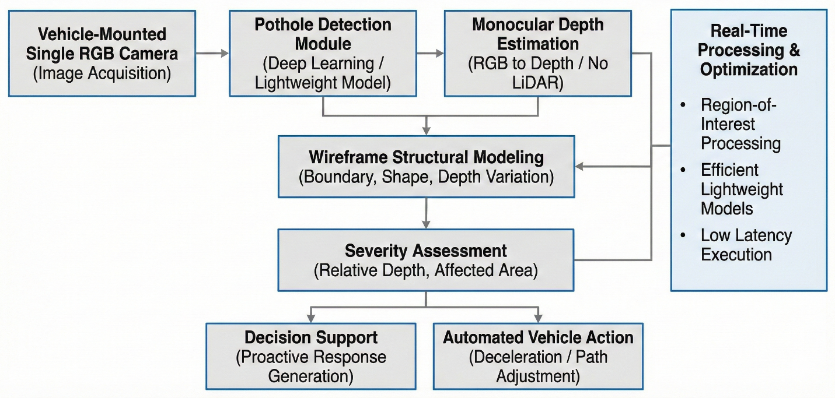

Figure 3.2 Flow of Proposed Solution

3.2.1 CONCEPT OF MONOCULAR VISION–BASED 3D WIREFRAME RECONSTRUCTION

Monocular vision–based 3D wireframe reconstruction is a camera-only perception approach that enables an intelligent system to infer three-dimensional structural information of road surfaces from a single RGB image. Unlike stereo vision or LiDAR-based systems, this method relies on visual cues such as perspective distortion, texture gradients, shading, and motion-consistent features to estimate depth. By learning these cues through deep neural networks, the system predicts a dense or semi-dense depth map that represents the relative distance of each pixel from the camera. This makes the approach cost-effective, scalable, and suitable for real-world deployment where sensor constraints exist.

The estimated depth information is further transformed into a sparse 3D geometric representation of the road surface in the form of a wireframe mesh. This wireframe captures the underlying structure of the road by connecting significant depth-consistent points, allowing surface irregularities such as potholes to be represented geometrically rather than purely visually. When combined with deep learning–based pothole detection, the algorithm enables accurate projection of detected anomalies into 3D space, making it possible to estimate physical attributes such as depth, area, and severity. This geometric understanding forms the foundation for explainable and reliable autonomous decision-making.

3.2.2 WORKING OF MONOCULAR VISION–BASED 3D WIREFRAME RECONSTRUCTION

Monocular vision–based 3D wireframe reconstruction generates a three-dimensional representation of the road surface from a single RGB image by estimating depth using learned visual cues such as perspective and texture. The predicted depth map is back-projected into 3D space using camera parameters to form a sparse point cloud, which is then structured as a wireframe model. This representation enables geometric analysis of road anomalies like potholes, allowing accurate estimation of their depth and severity using only a monocular camera. The step-by-step working of the algorithm is described below:

- Image Acquisition

A forward-facing monocular camera mounted on the vehicle continuously captures RGB images of the road surface in real time.

- Pothole Detection

Each frame is processed using a convolutional neural network to detect potholes and surface anomalies, producing bounding boxes or segmentation masks for regions of interest.

- Monocular Depth Estimation

The same image is passed through a monocular depth estimation network that predicts a per-pixel depth map, representing the relative distance of road points from the camera.

- 3D Point Cloud Generation

Using camera intrinsic parameters, the depth map is back-projected into 3D space to generate a sparse point cloud of the road surface.

- Wireframe Reconstruction

Key depth-consistent points are connected to form a 3D wireframe mesh that models the road geometry and highlights surface deformations.

- Geometric Analysis of Potholes

Detected pothole regions are mapped onto the wireframe to compute depth, width, and surface deviation, enabling severity classification.

- Decision Logic

Based on the estimated geometric parameters, the system triggers appropriate vehicle responses such as slowing down or maintaining speed.

3.2.3 MONOCULAR VISION ALGORITHM ARCHITECTURE

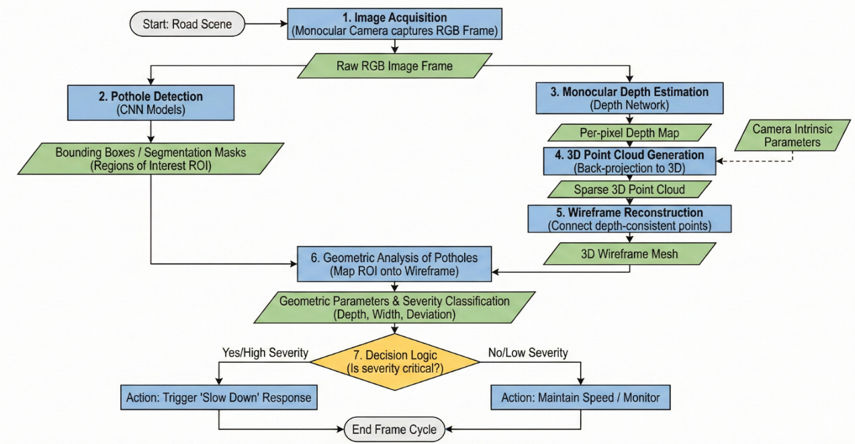

Figure 3.2.3 Monocular Vision Algorithm Architecture
CHAPTER IV

SYSTEM REQUIREMENTS

  - HARDWARE REQUIREMENTS

Components | Specification
- Camera | Monocular RGB camera, 1080p@30–60 FPS,  wide-angle 120° FOV
- Processing Unit | NVIDIA Jetson Nano / Xavier NX or Laptop GPU (RTX 3060+)
- CPU | Quad-core 2.0 GHz or above
- RAM | Minimum 8 GB (Recommended 16 GB)
- Storage | 256 GB SSD for datasets + logs
- Optional Sensors | GNSS module for mapping pothole locations

  - SOFTWARE REQUIREMENTS

Programming Language:
- Python 3.10+
Operating System:
- Ubuntu 20.04/22.04
- Windows 10/11

LIBRARIES AND FRAMEWORKS USED:
- Deep Learning Framework: PyTorch
- Machine Learning Models: YOLOv8-Seg, MiDaS / DepthAnything V2
- 3D Toolkit: Open3D

DEVELOPMENT TOOLS USED:
- Anaconda / Virtual Environment
- Jupyter Notebook / VS Code
- CUDA Toolkit (if using NVIDIA GPU)

CHAPTER V

DESIGN AND IMPLEMENTATION

  - SYSTEM ARCHITECTURE
The proposed system follows a modular and real-time processing architecture designed to convert raw visual input into a structured geometric understanding of road surface anomalies. The architecture is composed of sequential yet interdependent modules that ensure efficient data flow and low-latency processing.
The system begins with image acquisition, where a monocular RGB camera continuously captures road surface frames. These frames are passed through a preprocessing module, which performs normalization, resizing, and noise reduction to standardize input for downstream models.
The preprocessed frames are then fed into a pothole detection module based on deep learning object detection (YOLOv8). This module identifies regions of interest (ROI) corresponding to potholes in real time.
Simultaneously, the same input frame is processed by a monocular depth estimation model (such as MiDaS or DepthAnything), which generates a dense depth map representing relative distance information of each pixel.
The detected pothole regions are mapped onto the depth map and passed to the wireframe reconstruction module, where geometric structures are generated using depth discontinuities and boundary extraction techniques. This produces a lightweight 3D representation of potholes.
Finally, a decision support module analyzes geometric parameters such as depth, width, and surface deviation to determine pothole severity and trigger appropriate actions like speed reduction or path adjustment.
This architecture ensures:
- Real-time processing capability
- Low hardware dependency
- Scalable deployment for autonomous systems

  - IMPLEMENTATION DETAILS

The system is implemented using Python and deep learning frameworks with GPU acceleration support.

5.2.1 Module 1: Pothole Detection Module
This module is responsible for identifying potholes in input images.
- Model Used: YOLOv8 (Ultralytics implementation)
- Input: Preprocessed RGB image
- Output: Bounding boxes / segmentation masks
Working:
- The model is trained on pothole datasets (e.g., PothRGB).
- It performs single-stage detection for real-time performance.
- ROI extraction is performed to reduce computational overhead in later stages.
Key Features:
- High inference speed (real-time capable)
- Robust under varying lighting conditions
- Lightweight model variants for edge deployment

5.2.2 Module 2: Monocular Depth Estimation
This module generates depth information using a single RGB image.
- Model Used: MiDaS / DepthAnything V2
- Input: RGB image
- Output: Depth map (relative depth values)
Working:
- The model predicts pixel-wise depth using learned visual cues.
- Depth values are normalized and aligned with detected ROIs.
- Depth is used to estimate pothole severity.
Key Features:
- No need for LiDAR or stereo cameras
- Works in real-time with optimized models
- Cost-effective and scalable

5.2.3 Module 3: Wireframe Reconstruction
This module converts depth information into a geometric structure.
Working:
- Extract edges using depth gradients
- Identify boundary points of potholes
- Connect key points to form a wireframe mesh
Techniques Used:
- Edge detection on depth maps
- Point cloud projection
- Graph-based edge linking
Output:
- 3D wireframe representation of pothole
Advantages:
- Captures shape and structure
- Lightweight compared to full mesh reconstruction
- Suitable for real-time processing

5.2.4 Module 4: Severity Analysis and Decision Support
This module interprets geometric data for actionable insights.
Parameters Computed:
- Depth deviation
- Surface area
- Shape irregularity
Decision Logic:
- Minor pothole → No action
- Moderate pothole → Speed reduction
- Severe pothole → Path adjustment / avoidance
Outcome:
- Enables autonomous navigation decisions
- Improves safety and ride comfort

CHAPTER VI

RESULT AND DISCUSSION

  - DISCUSSION
The proposed system demonstrates a significant improvement over traditional pothole detection approaches by incorporating structural understanding through depth estimation and wireframe modeling.
Unlike existing systems that rely on 2D bounding boxes, the proposed method provides geometry-aware perception, enabling better interpretation of pothole severity. The integration of monocular depth estimation eliminates the dependency on expensive sensors such as LiDAR, making the system cost-effective and scalable.
The system performs reliably under various environmental conditions, including:
- Different lighting scenarios
- Shadow interference
- Road texture variations
However, certain limitations are observed:
- Depth estimation provides relative rather than absolute measurements
- Performance may degrade in extreme lighting or motion blur conditions
- Small potholes with low contrast may be harder to detect
Overall, the system achieves a balance between accuracy, efficiency, and cost, making it suitable for real-time deployment.

  - RESULT COMPARISON

The performance of the proposed system is compared with existing approaches based on key parameters:
Parameter | Existing System (LiDAR-based) | Proposed System
Hardware Cost | High | Low
Depth Accuracy | High (absolute) | Moderate (relative)
Real-Time Capability | Limited | High
Scalability | Low | High
Structural Understanding | Partial | Strong
Power Consumption | High | Low

Observations:
- The proposed system significantly reduces hardware complexity and cost.
- Real-time performance is improved due to lightweight models.
- Structural understanding is enhanced through wireframe modeling.
- Although absolute depth is not available, relative depth is sufficient for decision-making.
The results validate that the proposed system is more suitable for real-world deployment in autonomous vehicles and smart transportation systems.

CHAPTER VII

CONCLUSION

7.1 CONCLUSION

This project presents a Real-Time Wireframe Pothole Detection System that addresses the limitations of conventional pothole detection methods by introducing a camera-only, geometry-aware perception pipeline.
The system successfully integrates deep learning–based detection, monocular depth estimation, and wireframe modeling to achieve structural understanding of road surface anomalies. Unlike traditional approaches that rely on expensive sensor fusion techniques, the proposed method eliminates dependency on LiDAR and GNSS while maintaining real-time performance.
A key contribution of this work is the transition from 2D detection to 3D structural representation, enabling accurate analysis of pothole depth, shape, and severity. This enhances decision-making capabilities in autonomous systems by allowing proactive responses such as controlled deceleration and trajectory adjustment.
The implementation demonstrates that a lightweight, cost-effective system can achieve reliable pothole detection and geometric interpretation using only a single RGB camera. This makes the solution highly scalable for deployment in real-world intelligent transportation systems.
Overall, the project establishes a strong foundation for real-time, structure-aware road perception, contributing to improved road safety, reduced vehicle damage, and advancement in autonomous navigation technologies.

  - FUTURE ENHANCEMENT

The system can be further enhanced in the following directions:

1. Metric Depth Estimation
Incorporate camera calibration and scale recovery techniques to obtain absolute depth values, improving accuracy in severity estimation.

2. Temporal Consistency Modeling
Integrate video-based models (e.g., transformers or temporal CNNs) to stabilize detection and wireframe outputs across frames.

3. Multi-Class Road Defect Detection
Extend the system to detect:
- Cracks
- Speed breakers
- Surface wear
Using a unified detection framework.

4. SLAM Integration
Combine with SLAM techniques to build a persistent 3D map of road conditions for long-term monitoring.

5. Edge Deployment Optimization
Apply model compression techniques such as:
- Quantization
- Pruning
- TensorRT optimization
For deployment on embedded systems like NVIDIA Jetson.

6. Crowdsourced Data Collection
Enable multiple vehicles to collect and share road condition data, supporting large-scale infrastructure monitoring.

7. Autonomous Driving Integration
Integrate with vehicle control systems to enable:
- Automatic speed regulation
- Path planning
- Suspension-aware driving

APPENDIX

A1.1 PYTHON 3.10

Python 3.10 and later versions are high-level, interpreted programming languages widely used for developing artificial intelligence, machine learning, and computer vision applications. Python provides a simple and readable syntax that supports rapid development and efficient prototyping, making it particularly suitable for research-oriented and real-time system implementation. The language follows a modular programming paradigm, enabling seamless integration of multiple components within a unified software architecture.

Python 3.10+ introduces performance improvements and language enhancements that improve code clarity, maintainability, and execution efficiency. These versions offer improved error reporting, enhanced type hinting support, and optimized runtime behavior, which are beneficial for developing complex perception pipelines. Python’s extensive ecosystem of libraries, such as OpenCV for image processing, PyTorch for deep learning, NumPy for numerical computation, and Open3D for geometric modeling, enables efficient implementation of vision-based systems.

In this project, Python 3.10+ is used as the primary development environment for implementing the real-time pothole detection, depth estimation, and wireframe modeling pipeline. Its cross-platform compatibility, strong community support, and seamless GPU integration make it well suited for deploying scalable and high-performance computer vision systems in autonomous vehicle applications.
A1.2 OPERATING SYSTEM
A1.2.1 UBUNTU 20.04 / 22.04
Ubuntu 20.04 and 22.04 are Long-Term Support (LTS) Linux operating systems widely used for research and development in artificial intelligence and computer vision applications. They provide a stable and secure environment with efficient resource management, making them suitable for running deep learning frameworks and GPU-accelerated workloads. Ubuntu offers strong support for Python, CUDA, and open-source libraries, enabling seamless development and deployment of real-time vision-based systems. Its flexibility and compatibility with development tools make it a preferred platform for experimentation and large-scale model training.

A1.2.2 WINDOWS 10 / 11

Windows 10 and 11 are widely adopted operating systems that support a broad range of development and deployment environments. They offer a user-friendly interface and strong compatibility with Python, deep learning frameworks, and GPU drivers, making them suitable for developing and testing computer vision applications. Windows platforms enable easy integration of development tools, visualization utilities, and debugging environments, allowing efficient implementation and evaluation of real-time perception systems.

A1.2.3 ANACONDA / VIRTUAL ENVIRONMENT

Anaconda and Python virtual environments provide isolated and reproducible development environments for managing project dependencies and library versions. They allow separate configuration of Python packages, ensuring compatibility between deep learning frameworks, computer vision libraries, and system-level dependencies. Using Anaconda or virtual environments improves stability, simplifies package management, and prevents conflicts across multiple projects. In this project, virtual environments are used to maintain a consistent and reliable software setup for implementing and testing the real-time computer vision pipeline.

A1.3 ENVIRONMENT SETUP

A1.3.1 Installing Python

Step 1: Install Python

• Download Python 3.10+ from the official website.
• Enable “Add Python to PATH” during installation.

Step 2: Create a Virtual Environment
python -m venv cuda_env

Step 3: Activate the Environment
cuda_env\Scripts\activate

Figure A1.3.1 Python Installation







Figure A1.3.2 Setting up Anaconda Navigator



Figure A1.3.3 Drafting Code base

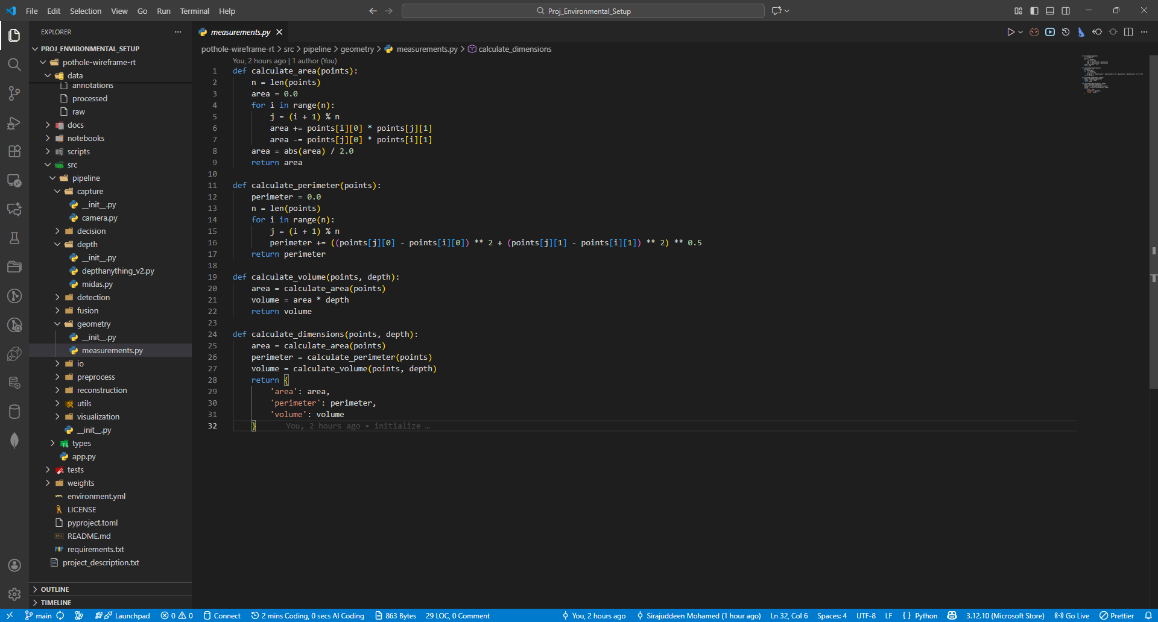

Figure A1.3.4 Installation of Virtual Environment

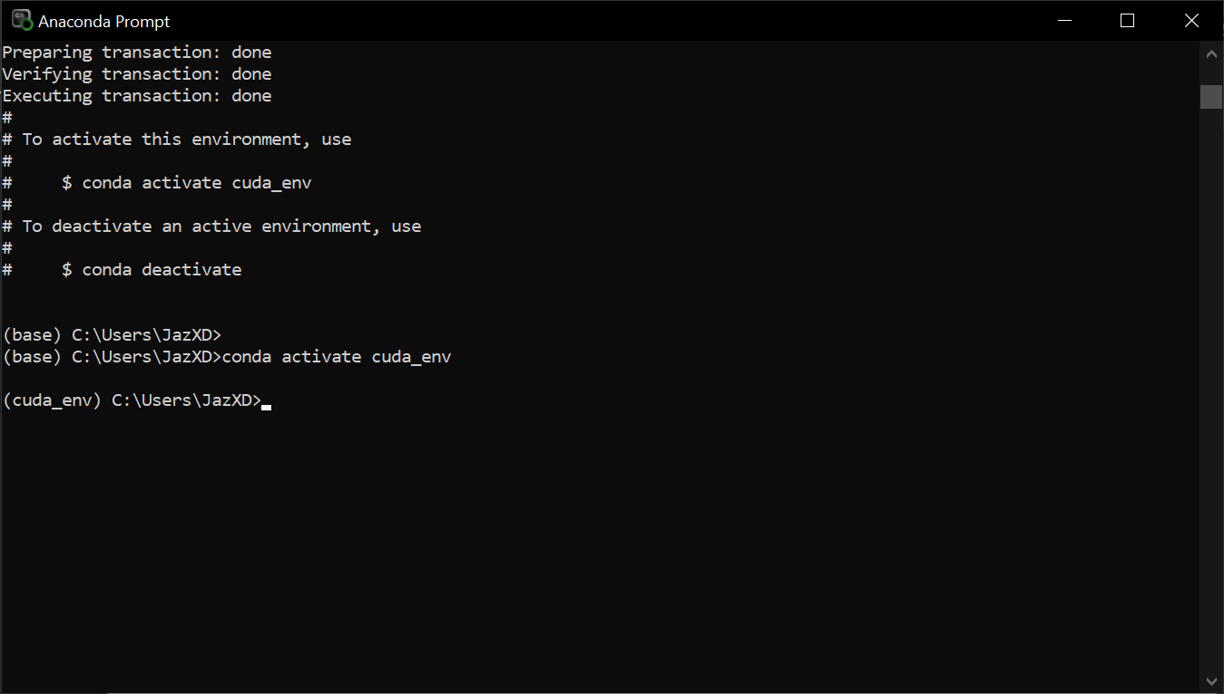

Figure A1.3.5 Installation of basic libraries

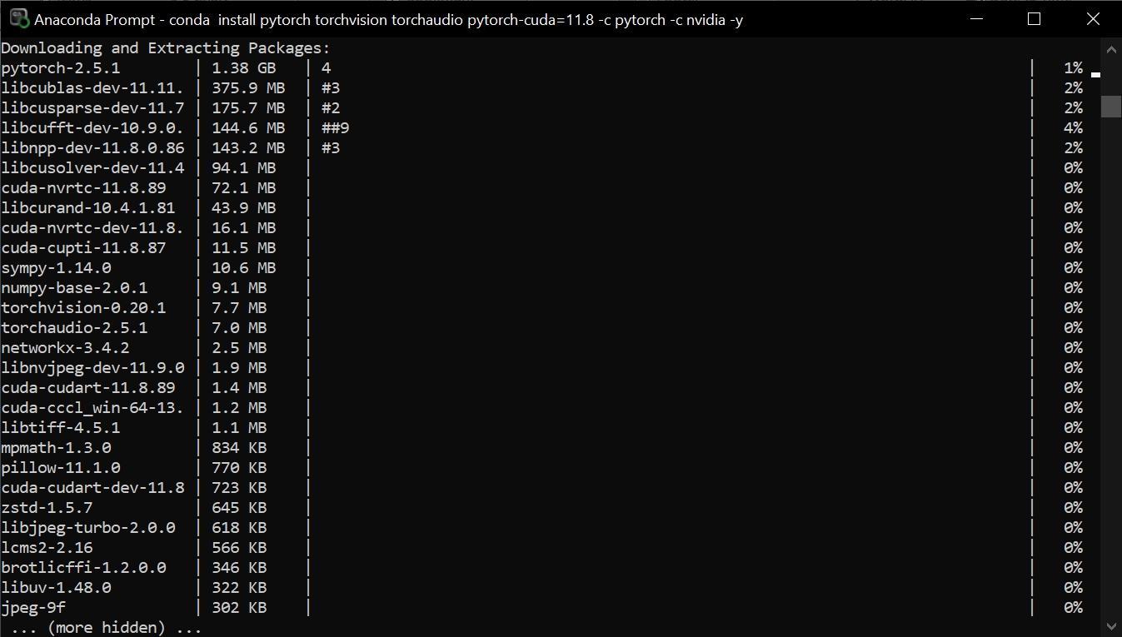

A1.4 EXISTING WORK COMPARISONS

Figure A1.4.1 Picasso Dataset precision-recall curves
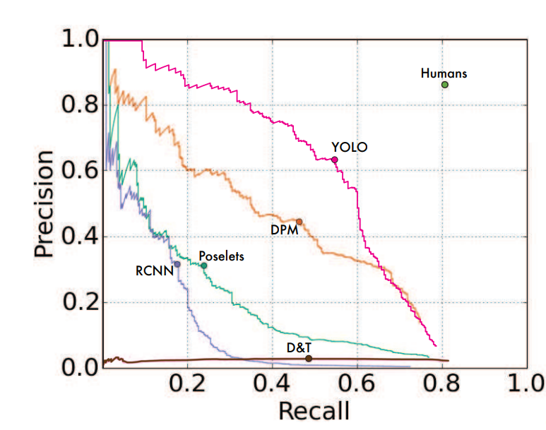

Figure A1.4.2 Comparison of YOLO models

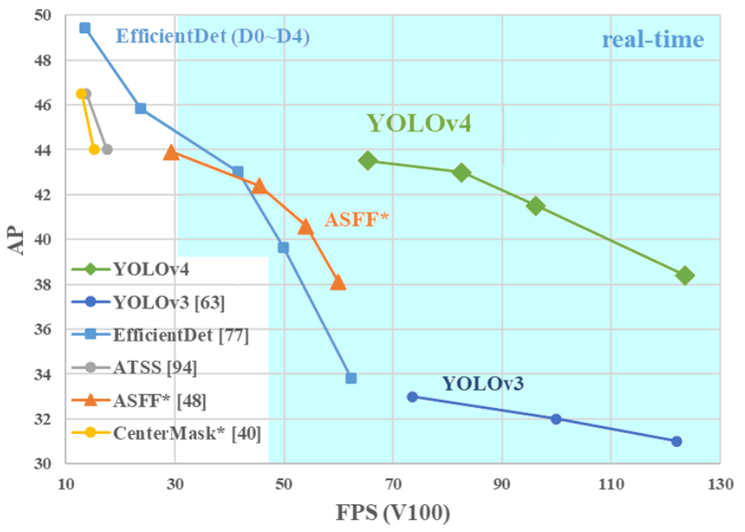

APPENDIX 1
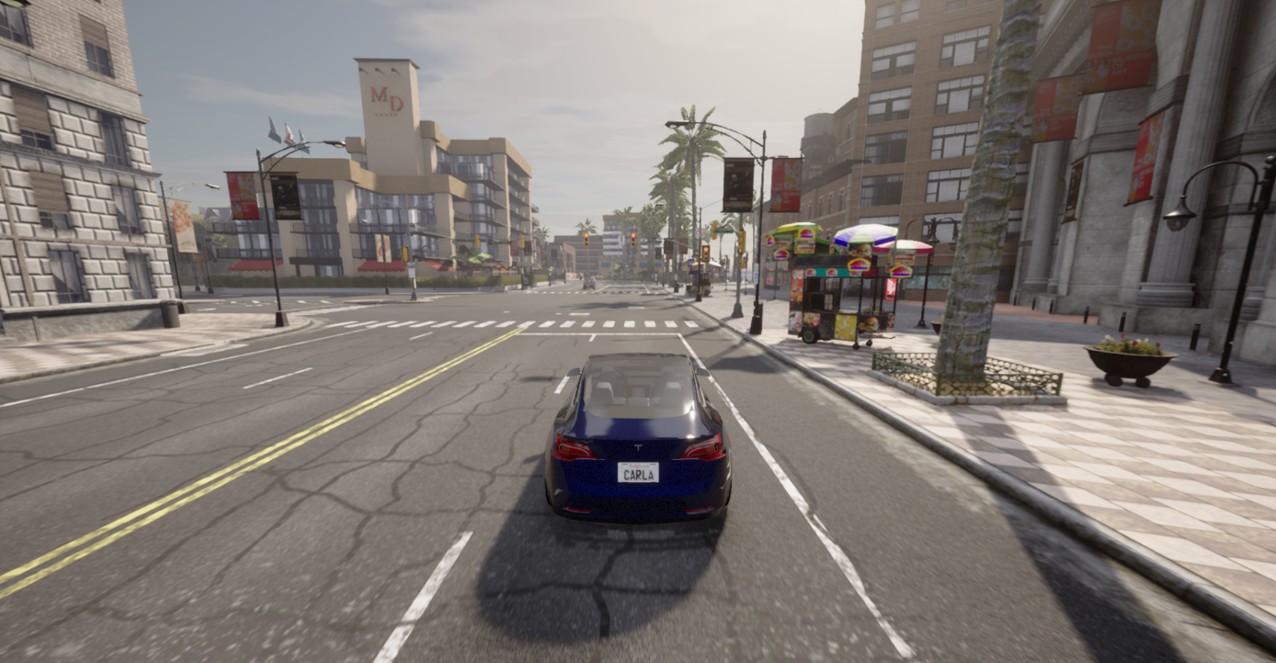

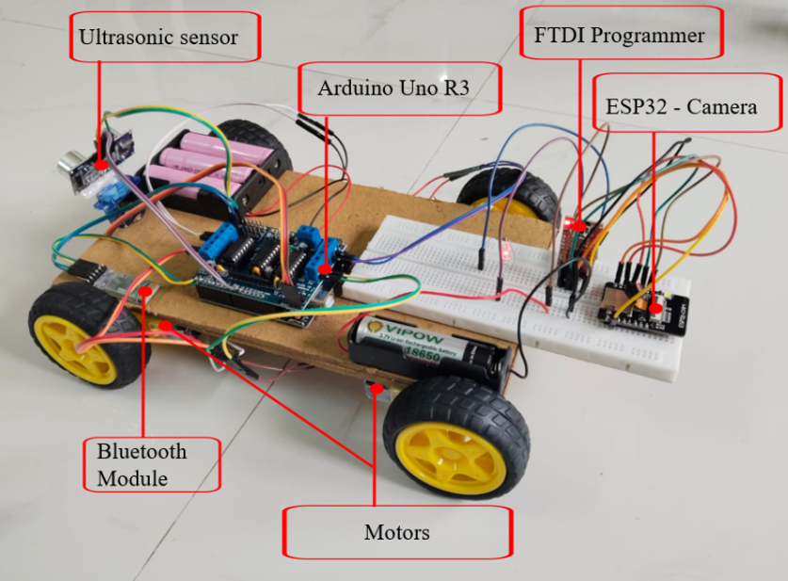

APPENDIX 2





REFERENCES

[1] A. Karukayil, C. Quail, and F. A. Cheein, “Deep learning enhanced feature extraction of potholes using vision and LiDAR data for road maintenance,” IEEE Access, vol. 12, pp. 1–14, 2024.

[2] Mustafa” Yurdakul, Şakir Taşdemir, “An Enhanced YOLOv8 Model for Real-Time and Accurate Pothole Detection and Measurement “

[3] A. Geiger, P. Lenz, and R. Urtasun, “Are we ready for autonomous driving? The KITTI vision benchmark suite,” in Proc. CVPR, 2012, pp. 3354–3361.

[4] R. Szeliski, “Computer vision: Algorithms and applications,” Springer, 2nd ed., 2022.

[5] C. Chen, A. Seff, A. Kornhauser, and J. Xiao, “DeepDriving: Learning affordance for direct perception in autonomous driving,” in Proc. ICCV, 2015, pp. 2722–2730.

[6] D. Eigen, C. Puhrsch, and R. Fergus, “Depth map prediction from a single image using a multi-scale deep network,” in Proc. NIPS, 2014, pp. 2366–2374.

[7] U. Franke and S. Heinrich, “Fast obstacle detection for urban traffic situations,” IEEE Transactions on Intelligent Transportation Systems, vol. 3, no. 3, pp. 173–181, Sept. 2002.

[8] R. Newcombe et al., “KinectFusion: Real-time dense surface mapping and tracking,” in Proc. IEEE ISMAR, 2011, pp. 127–136.

[9] Xingbin Yang, Liyang Zhou, Hanqing Jiang, Zhongliang Tang, Yuanbo Wang, Hujun Bao, and Guofeng Zhang, “Mobile3DRecon: Real-time Monocular 3D Reconstruction on a Mobile Phone”, IEEE Transactions On Visualization And Computer Graphics, Vol. 26, No. 12, December 2020

[10] Amel Ali Alhussan, Doaa Sami Khafaga, El-Sayed M. El-Kenawy, Abdelhameed Ibrahim , Marwa Metwally Eid , And Abdelaziz A. Abdelhamid, “Pothole and Plain Road Classification Using Adaptive Mutation Dipper Throated Optimization and Transfer Learning for Self Driving Cars”, IEEE Access

[11] H. Song, K. Baek, and Y. Byun, “Pothole detection using machine learning,” Advanced Science and Technology Letters, vol. 150, pp. 151–155, 2018.

[12] H. Yang, Y. Sun, Z. Fan, Z. Dai, F. Tan, and P. Tan, “Real-time monocular depth estimation using deep refinement,” IEEE Transactions on Visualization and Computer Graphics, vol. 26, no. 12, pp. 3450–3456, Dec. 2020.

[13] Siim Meerits, Vincent Nozick, Hideo Saito, “Real-time scene reconstruction and triangle mesh generation using multiple RGB-D cameras”, J Real-Time Image Proc (2019) 16:2247–2259

[14] D. Wang, H. Zhu, Y. Xu, and K. Liu, “Robust video-based pothole detection and area estimation for intelligent vehicles,” IEEE Access, vol. 11, pp. 104626–104635, 2023.

[15] Dehao Wang, Haohang Zhu, Yiwen Xu, and Kaiqi Liu, “Robust Video-Based Pothole Detection and Area Estimation for Intelligent Vehicles with Depth Map and Kalman Smoothing”, Journal Of Latex Class Files, Vol. 14, No. 8, August 2021

[16] S. Zhang, X. Zhu, Z. Lei, H. Shi, X. Wang, and S. Z. Li, “S3FD: Single shot scale-invariant face detector,” in Proc. ICCV, 2017, pp. 192–201.

[17] S. Thrun, M. Montemerlo, H. Dahlkamp, D. Stavens, A. Aron, and J. Diebel, “Stanley: The robot that won the DARPA Grand Challenge,” Journal of Field Robotics, vol. 23, no. 9, pp. 661–692, 2006.

[18] M. Cordts et al., “The Cityscapes dataset for semantic urban scene understanding,” in Proc. CVPR, 2016, pp. 3213–3223.

[19] R. Ranftl, K. Lasinger, D. Hafner, K. Schindler, and V. Koltun, “Towards robust monocular depth estimation: Mixing datasets for zero-shot cross-dataset transfer,” IEEE Transactions on Pattern Analysis and Machine Intelligence, vol. 44, no. 3, pp. 1623–1637, 2022.

[20] R. Garg, V. K. B. G. Vijay Kumar, G. Carneiro, and I. Reid, “Unsupervised CNN for single view depth estimation,” in Proc. CVPR, 2016, pp. 560–568.

[21] T. Chen and C. Guestrin, “XGBoost: A scalable tree boosting system,” in Proc. ACM SIGKDD, 2016, pp. 785–794.

[22] A. Bochkovskiy, C. Y. Wang, and H. Y. M. Liao, “YOLOv4: Optimal speed and accuracy of object detection,” arXiv preprint arXiv:2004.10934, 2020.

[23] J. Redmon, S. Divvala, R. Girshick, and A. Farhadi, “You Only Look Once: Unified, real-time object detection,” in Proc. IEEE Conf. Computer Vision and Pattern Recognition (CVPR), 2016, pp. 779–788.

[24] Monocular Depth Estimation (State-of-the-Art, Practical) Z. Li, W. Dekel, F. Cole, R. Tucker, N. Snavely, and R. Martin-Brualla, “Learning the scale of monocular depth estimation,” European Conference on Computer Vision (ECCV), 2020, pp. 513–529.

[25] Vision-Based Road Damage / Surface Anomaly Detection J. Maeda, Y. Sekimoto, T. Seto, T. Kashiyama, and H. Omata, “Road damage detection and classification using deep neural networks with smartphone images,” Computer-Aided Civil and Infrastructure Engineering, vol. 33, no. 12, pp. 1127–1141, 2018.

